**Screenshots:**

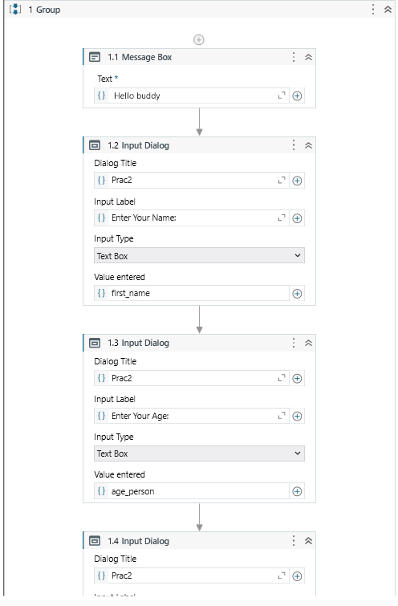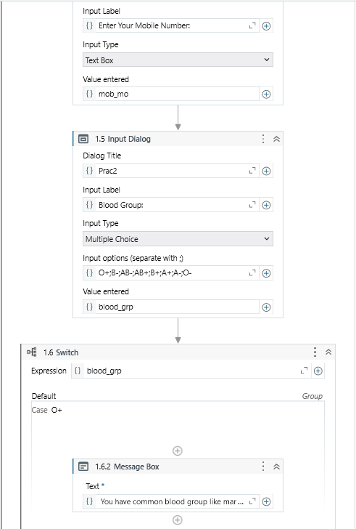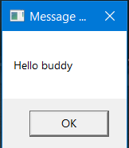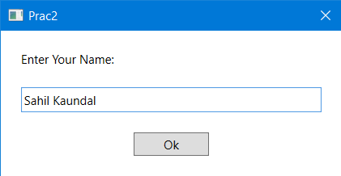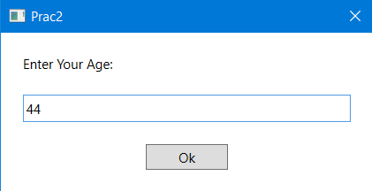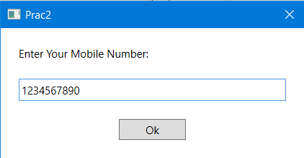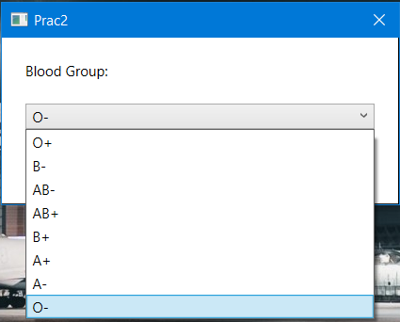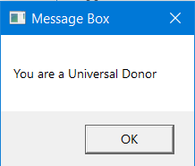

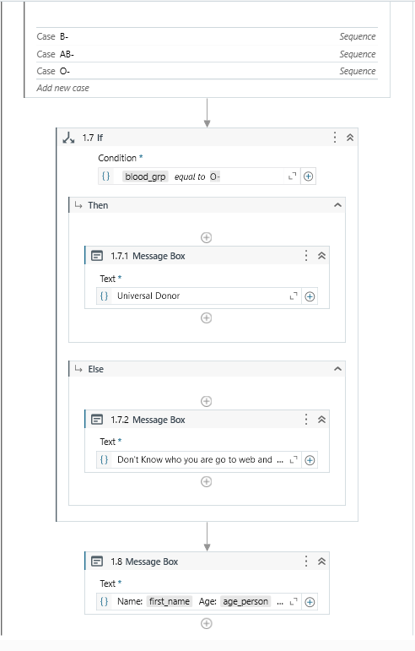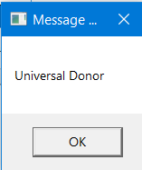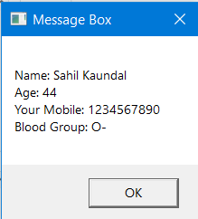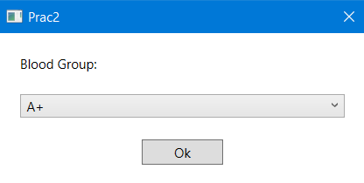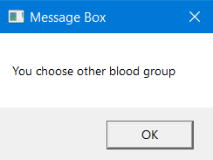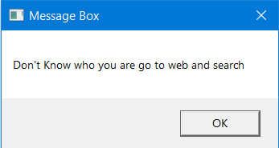

**AIM:**Create a reliable and effective script that automates the sequential steps of a predefined automated process.

**SOFTWARE REQUIRED*:***Any RPA Tool (UiPath, Blue Prism, Automation Anywhere)

**RELEVANCE OF THE EXPERIMENT:**The experiment involving the creation of a reliable and effective script to automate the sequential steps of a predefined process is of paramount relevance in the domain of automation development. This practical exercise addresses critical aspects that contribute to the success and efficiency of Robotic Process Automation (RPA) initiatives.

**DESCRIPTION:** In this practical exercise, participants will design a reliable and effective script using UiPath's drag-and-drop approach to automate a predefined sequence of steps in a structured manner. Emphasizing variables, conditional statements, and sequences, this hands-on experience aims to impart the skills needed for crafting efficient and adaptable automation workflows within the UiPath environment.

**1.  Open Application:**  Use the "Open Application" activity to launch the target application.  
**2:  Login:** Utilize "Type Into" activities to input the username and password into the login fields.  
**3:  Navigate to a Module:** Use "Click" activities to navigate to a specific module or section within the application.  
**4:  Extract Data:** Employ data extraction activities (e.g., "Get Text") to capture relevant information from     the application.  
**5:  Process Data:** Implement data processing activities or calculations using "Assign" activities or Invoke Code activities.  
**6:  Update Records:** Use automation activities, such as "Type Into" or "Click," to update records or perform any necessary actions.  
**7:  Save or Submit:** Incorporate activities to save changes or submit forms within the application.  
**8:  Log Results:** Add logging activities to record important information or results for later analysis.  
**9:  Close Application:** Use the "Close Application" activity to gracefully exit the application.  
**10: Exception Handling:** Implement "Try-Catch" activities to handle exceptions gracefully, providing error messages or taking alternative actions.  
**11:  Clean Up:**Include activities to clean up temporary files or resources if necessary.  
**12:   End:** Conclude the script with the necessary cleanup activities and an indication of completion.

**LEARNING OUTCOMES**

The students will

i.             Develop a comprehensive understanding of the predefined automated process, including its sequential steps, dependencies, and variation.

ii.           Gain technical proficiency in the chosen scripting language and RPA tool, demonstrating the ability to apply programming concepts to automate manual processes.

iii.        Acquire hands-on experience in script development, translating the steps of the predefined process into executable code while maintaining accuracy and efficiency.